LOSS AND FRAGMENTATION OF HABITAT FOR PASTORAL PEOPLE AND WILDLIFE IN EAST AFRICA: CONCEPTS AND ISSUES

RS Reid^{a,b}, PK Thorntonª, and RL Kruskaª

ª International Livestock Research Institute (ILRI), PO Box 30709, Nairobi, Kenya
^{b} Natural Resource Ecology Lab, Colorado State University, Fort Collins, Colorado, USA

INTRODUCTION

Much of the conceptual thought and practical examples of both habitat loss and fragmentation describe what happens when people or physical events change parts of ‘intact’ forests into other land cover or land use types, particularly in temperate regions (Harris 1984, Forman & Godron 1986, Turner & Gardner 1991). More work has measured habitat loss (change in amount) than fragmentation (change in spatial pattern) and few studies have separated cause and effect through manipulative experiments (McGarigal & Cushman 2002). Of these remaining rarities, few also investigated the range of forces that cause loss and fragmentation, and fewer still took an integrated view of both ecological and economic consequences of these processes.

In pastoral lands, scientists and managers have long highlighted the high degree of landscape heterogeneity or vegetation pattern (e.g., Pickup & Chewings 1994), but rarely have conducted observational or experimental studies on habitat loss or fragmentation caused by human action. In a recent review of fragmentation papers in major ecological journals (McGarigal & Cushman 2002), only 5% studied loss and fragmentation in deserts, steppe or grassland.

We wrote this paper to explore the relatively uncharted land of rangeland loss and fragmentation. In this paper, we will discuss these issues with respect to East African pastoral systems to better understand the causes and consequences of habitat loss and fragmentation from the perspective of people, their livestock, and wildlife (particularly charismatic mega-fauna). We will do this first by developing a conceptual framework for rangeland loss and fragmentation and then by using three case studies to illustrate the ecological and economic consequences of these changes. We then present a preliminary map estimating where loss and fragmentation may be occurring in African rangelands today. We will then highlight unresolved issues that require further thought and testing.

WHAT IS “LOSS AND FRAGMENTATION” FROM A RANGELANDS PERSPECTIVE?

There is considerable conceptual confusion about what loss and fragmentation actually mean, partly because the definition of the latter term, fragmentation, has changed recently (Villard 2002). Originally, fragmentation referred to both the loss (change in amount of habitat) and fragmentation (change in the spatial arrangement of habitat pieces), partly because one usually follows the other. The problem is that loss and fragmentation ‘give rise to different ecological processes and should, for sake of clarity, be held separate’ (Haila 2002, p. 321). Today, most investigators separate the two conceptually even though some argue that they usually happen simultaneously (e.g., McGarigal & Cushman 2002) while others claim they occur separately (Fahrig 1997). Despite the progress in clarifying the definitions of loss and fragmentation, only 6% of recent field studies actually attempted to measure the effects of these two processes separately and almost none did so experimentally (McGarigal & Cushman 2002).

One of the missing elements of these definitions is that habitat is often modified without being lost, signifying a loss in quality rather than quantity of the remaining habitat. This often happens, like loss, at the same time as changes in spatial pattern of the habitat (=fragmentation). Thus, we choose to recognize three principal processes of habitat change. Habitat loss or conversion is a direct change in the composition of the elements of a rangeland landscape, which changes a suitable habitat so that it is entirely unsuitable for a user. An example of this is when a farmer ploughs a savanna to cultivate crops or urban centers expand into rangelands – habitat for certain wild herbivores is lost. Another example is the impenetrable fencing of a wetland, so that the access of wildlife and livestock is completely blocked. Sometimes the blockage is not physical: changes in ownership can prevent people and livestock from accessing parts of landscapes where no barriers are present. Of course, if farmers fallow their crops or remove fences, this habitat may recover and become suitable again in the future. Habitat modification (or partial loss) is a change in quality of the habitat so that it is no longer entirely suitable for the user. An example of this is a heavily grazed area around a settlement or water point – the habitat is less suitable but not entirely unusable for many species of wild herbivores. Another is a fence that some individuals of a population can jump over or crawl under while others cannot because it is too tall. If habitat is either lost or modified, it usually also becomes fragmented: the pieces of the rangeland break up into smaller pieces or patches. For example, when settlers establish a village in a rangeland, they convert rangeland to village use wherever they build homes, shops and schools. While this obviously results in loss of habitat, it also changes the size, shape, numbers, and configuration of the patches of land within the remaining rangeland.

In rangelands, loss and modification are almost always accompanied by fragmentation, but not necessarily the other way around. The very process of destruction or reduction in the quality of part of a habitat also breaks the habitat into pieces or fragments it, unless the entire habitat is lost. However, when we build a linear feature in a rangeland (a road or a railway, for example), the principal process initiated is fragmentation, not loss or modification. Although very little of the landscape is lost or modified (under the road or rail bed), elephants will change their behaviour and movement patterns because of the traffic on a road (Barnes et al. 1991). In this case, the minor loss of habitat under the road caused modification and fragmentation of much of the surrounding habitat (from an elephant’s point of view).

What is unseen in these definitions is an answer to the essential question: for whom? None of the three processes described above has any meaning if the user of the habitat is not specified. In other words, fragmentation to an elephant may be entirely different than fragmentation to a dung beetle (Table 1). Thus loss, modification and fragmentation are conceptually unclear unless used with careful reference to the habitat needs of the user. In this paper, we include humans and livestock as users and definers of ‘suitable habitat’. This is particularly important in rangelands because traditional pastoral peoples and their livestock respond to features of their environment in ways analogous to wild species, much more than peoples in farming systems.

Table 1: Examples of the causes, processes and probable consequences of fragmentation found in the rangelands of East Africa from the point of view of particular habitat ‘users’.

Habitat ‘User’ | Cause of habitat change that limits access to a smaller spatial area | Probable consequence of habitat change
Cow | Cessation of nomadic movement, conversion from rangeland to cultivation, fences, new rules about use (land tenure), change in grazing system boundaries as a result of pastoral conflict, national warfare | Conversion of habitat, decreased diversity of vegetation patches, lower and more variable animal production, increased pastoral vulnerability
Wildebeest | Fences, competition for forage with livestock, climate change, lack of water and forage seasonally, increased predation, conversion of rangeland to cultivation, exclusive use of water points by pastoral people | Population loss and extinction, increased morbidity and mortality, reduced gene flow among populations
Elephant | Fences (although rarely), increased number of roads or villages, increased numbers of domestic dogs | Change in behavior and production, reduced removal of woody vegetation by elephants
Termite | Changes in browser:grazer ratios, bush cutting that removes wood vegetation food resources, climate change | Decrease productivity and abundance of termites, slower decomposition rates
Slow- moving insect | Increased soil surface disturbance (livestock trampling) | Higher energetic costs
Dung beetle | Land management changes that result in changes in herbivore populations | Slower decomposition of organic matter, changed soil bacterial populations

CAUSES OF LOSS AND FRAGMENTATION IN RANGELAND ECOSYSTEMS

The causes of fragmentation can be bio-physical, social, or both, endogenous or exogenous in origin, and can be effective at a variety of scales (Figure 1). They are set within the historical context of centuries of interactions of different cultures in East Africa. For example, fragmentation can be caused biophysically by a change in the availability of forage or water by season or year. Savanna fires, when caused by lightning strikes, are a biophysically derived cause of the modification and fragmentation of forage resources. However, most of the causes of loss and fragmentation fall into the social realm because humans dominate the forces of change in rangelands today. Many of the apparently biophysical driving forces (climate change, geomorphological events) are caused directly or indirectly by human action. Across the globe, human activities often fragment rangelands through housing developments, road construction and recreational activities (Huenneke & Noble 1996). In a South American grassland, fences, roads, railways, and power lines serve to fragment a pampas grassland (Guersa & Leon 1999). Many of the same general causes of habitat change that apply to rangelands across the globe also take place in East Africa: human population growth (intrinsic but especially through migration), land use and management policy, introduction of improved technologies, armed conflicts, local and international market opportunities, and infrastructure development.

We suggest that many of these causes originate from forces both within and outside of pastoral systems. Essentially, the principal drivers of fragmentation in rangelands in East Africa are endogenous responses by peoples (both migrants and residents) living in these landscapes to a combination of: 1) opportunities to take advantage of new options (these might be thought of as ‘pull’ factors) and 2) pressures that make old livelihood options less viable (‘push’ factors). In the first instance, people in pastoral lands (as elsewhere) are opportunistic, connected to the world around them, and want the same societal goods and services that people have in higher potential areas. They want good health care for themselves and their livestock, schooling for their children, and access to technology. This affects how people use the land; for example, many pastoral families have decided to establish a permanent settlement, either as a primary residence or as a complement to a nomadic herding residence. The permanent residence provides the platform for access to schools, health care and rural urban opportunities. The nomadic residence provides access to land and forage for livestock herds. New external market opportunities, like those for high cost vegetables or ecotourism, provide pastoralists new opportunities to expand family incomes. In the second instance, they are pushed to seek new ways to buffer the increased risks that they face, because of dwindling access to land, climate change, loss of land productivity and insecurity (driven by many of the forces described in the previous paragraph). For example, these pressures caused, some years ago, household members to began to seek employment outside rangelands to provide additional income. Cultivation of subsistence crops for home consumption also provides a relatively simple means of buffering household food insecurity. This intensification and diversification of the pastoral economy (Sperling & Galaty 1990, Smith 1999) results in an increased dependence on cash income, and cultivation is incorporated as a household strategy wherever this is possible (Rigby 1985).

At the household level, many of these forces, whether endogenous or exogenous, cause families to become less socially coherent with different family members living in different places within and outside of pastoral systems. Many households find that income diversification makes them less vulnerable to the range of stresses that they face in pastoral lands. This ‘social’ fragmentation and diversification brings different norms and values into pastoral families and lands, as indigenous pastoral peoples adopt new ways of land use and newcomers bring their traditional ways from elsewhere that are often very different from those of pastoral peoples. In some areas, the values and norms of agriculturalists (either adopted by former pastoralists or with the influx of newcomers) are coming to dominate the land-use decisions in the higher potential rangelands or areas with key resources within dry rangelands (Campbell et al. 2000). In some traditional pastoral communities, this is having an impact on the levels of inter-household social cooperation, resulting in reduced transfers of food and cash between richer and poorer households and increasing the vulnerability of the less well-off (Smith 1999).

Although, as we will show later in Fig 2., these land-use decisions do not dominate pastoral lands by area, they disproportionately affect the important areas with water that most organisms in rangelands need to use in order to survive. For example, in the rangelands at the base of Mt. Kilimanjaro, agro-pastoralists and agriculturalists (both small-scale and large-scale farming enterprises) are converting precious swamplands and riverbanks into crops for local and national markets (Campbell & Lusch 2003). Smallholder farmers now use well-watered areas at the base of the Nguruman escarpment in south-central Kenya to produce French green beans for international export. A large-scale farming enterprise will soon produce coffee for export in a de-gazetted portion of the wetter part of Pianupe National Park in Uganda (R. Lamprey, pers. comm.).

In the examples above, many of the driving forces or causes originate at one level of scale and have consequences for another. International development assistance encouraged Il-Ngwesi pastoralists in northern Kenya to convert rangeland into a community-managed wildlife conservation area. Demand for wheat at a national and regional scale in East Africa made conversion of rangeland to cropland in the Mara ecosystem profitable. National wildlife policy in Tanzania and the establishment of wildlife management areas may soon entirely change the way communities manage rangelands. Likewise, landscape-level changes like increases in livestock populations caused by local disease control projects have global-scale impacts through increased methane emissions. We conclude that we must better understand these connections among different scales (local → landscape → regional → global) if we are to better estimate future changes in rangeland loss and fragmentation (e.g., Turner et al. 1990).

Lastly, many of the driving forces of fragmentation can be indirect, working through other driving forces. For example, drought in northern Ethiopia caused policy makers to develop a resettlement policy to give agro-pastoralists access to new land outside the drought-prone zone in higher potential grazing land. Research on rangeland loss and fragmentation currently gives scant attention to potential indirect effects and positive and negative feedbacks.

PROCESSES AND CONSEQUENCES OF FRAGMENTATION

Processes
What are the specific processes that occur in response to these driving forces? Conversion of rangeland to cropland, village or urban land, quarries, roads, railroads, and airports can make habitat entirely or partially unusable (loss or modification) for users and almost always breaks habitat into smaller pieces of different sizes and shapes. Fences can either have no effect on users or can partially or wholly exclude individuals from parts or the entirety of landscapes. Land policy (land tenure, wildlife conservation areas) can erect invisible but effective barriers preventing access by animals of large body size (people, livestock, large wildlife), but may have no effect on small-bodied animals or plants. Savanna fires can temporarily change the suitability of habitat for users (more modification than loss). Intensive bushmeat hunting does not change the habitat itself, but makes access to the habitat for target species difficult. We hypothesise that the processes of modification of habitat often precede and are more common than those of habitat loss.

The processes of habitat loss and fragmentation can be complex in direction, speed, cause and effect. Changes in expansion of agriculture can be bi-directional and can vary in speed, with both expansion and contraction of cultivation possible (Conelly 1994, Snyder 1996) occurring within the same landscape, sometimes slowly and sometimes rapidly. This dynamism in the speed and direction of change significantly complicates attempts to understand current fragmentation and predict future ones.

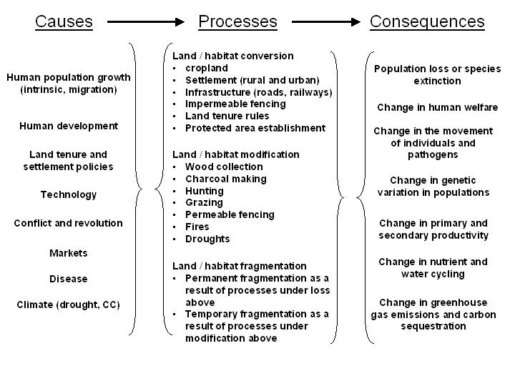

Figure 1. A conceptual framework of the causes, processes and consequences of the loss, modification and fragmentation of rangelands in East Africa.

Ecological and economic consequences
The ecological consequences of habitat change are complex (Villard 2002), and very few of the published examples are from rangelands. When habitat is lost, individuals are lost, which results in population declines directly (Schmiegelow & Monkkonen 2002). When habitat is modified or fragmented, population processes are often less affected, reducing the persistence of populations (Fahrig 2002). Habitat loss and fragmentation has caused the following ecological changes (Haila 2002): 1) reduction in the abundance and richness of species, 2) decreased dispersal among fragments, 3) changes in the fitness of species and populations, 4) loss in genetic variation, 5) breeding failure, 6) changes in competition exclusion relationships, and 7) changes in biophysical environment (microclimate, soils). Ecologists view the size, shape and configuration of the patches and the surrounding landscape as crucial to a whole set of ecological functions from the number of species a landscape can support to the speed at which pathogens or elephants can move through a landscape (e.g., Castello, Leopold & Smallidge 1995).

Examples from outside Africa suggest that the effects of loss are greater than those from fragmentation. In temperate forests of North America, the amount of forest had much more influence on the numbers of birds than the pattern of the forest (McGarigal & McComb 1995, Fahrig 2002). The effects of fragmentation varied depending on how much of the original habitat was left: the less habitat left, the bigger impact fragmentation had on extinction risks (Tscharntke et al. 2002). We expect that these patterns will also hold true for rangelands in Africa. Species that reproduce slowly are most likely to go extinct because of habitat loss and fragmentation (With & King 1999).

Sometimes fragmented habitat is more attractive to species than un-fragmented habitat. For example, in a temperate forest, smaller forest fragments supported more birds than larger ones, per unit area (McGarigal & McComb 1995). Expansion of farmland into grassland also increased the diversity of bird and tree species in southwestern Ethiopia (Reid et al. 1997, Wilson et al. 1997). Human use can increase the horizontal and vertical complexity of vegetation, especially in grasslands, which may explain these increases in species numbers.

The complexity of ecological consequences described above arises for several reasons (Villard 2002). Perhaps most important is that the effects of loss and fragmentation can be different for each species or ecological process. The imprint of a giraffe’s foot may fragment a landscape for a small beetle, but building a tall fence may not. Consequences may be short or long-lived. A passing savanna fire may change the productivity of the vegetation (and thus habitat quality) for a few months; construction of a village center may alter vegetation productivity for centuries. Effects will differ depending on the structure of the landscape: removal of forest may have more effect than the removal of grassland; further fragmentation in a highly fragmented landscape may have less impact than when the landscape first starts to break apart.

There is very little published on the economic costs of fragmentation, especially for rangelands. Any of the ecological changes described above could be put into monetary terms, as losses in ecosystem goods and services. There are also significant costs and benefits of loss and fragmentation for the returns to land for food production, as shown by the examples in the next section.

CASE STUDIES OF LOSS AND FRAGMENTATION IN EAST AFRICA

Case 1: The consequences of exclusion of pastoral people from conservation areas
In East Africa, about 10% of the land area is protected in national parks, reserves and other conservation areas (WRI 2000). Most of the protected areas in rangelands were created where there are congregations of wildlife in the dry (or difficult) season: in areas of slightly higher rainfall or around key water resources (swamps, rivers). These sparse but important areas are the lifeblood of rangelands when times are most difficult. Thus even though protected areas cover a small portion of the East African savannas, these small areas contain a disproportionate amount of the key resources that ensure survival of pastoral people, wildlife, livestock and other organisms in these ecosystems.

Creation of these protected areas in the last half century provides an unconventional example of fragmentation in rangelands. Through a set of local and national policy initiatives, pastoral peoples and their livestock were prohibited from using key areas of range landscapes. People and livestock have been part of these landscapes for the last 3000 years, but humans and our hominid ancestors have lived side-by-side with wildlife for far longer (at least 3.7 million years, Leakey & Hay 1979). In a few cases, like the Ngorongoro Conservation Area in Tanzania, people and livestock were allowed to remain in the conservation area, but this is exceptional. In general, all use was prohibited, although encroachment by pastoralists on conservation area boundaries is common (and often tacitly tolerated) today.

Exclusion of people from these landscapes may have some unintended impacts. For all the protected areas in Kenya, the returns from tourism are only 20% of what could be earned from using these protected areas for crop and livestock production (Norton-Griffiths & Southey 1995). For the flagship parks, the returns are much higher than average and thus tourism use is an economically viable land use compared with agriculture. Even where the returns are high, they are often garnered by the elites in local and national communities, with little to no revenues flowing to the poor (Thompson & Homewood 2002). Thus, establishment of parks has been uneconomical in most cases from a local point of view; and when tourism is more profitable than other uses, only a wealthy few benefit.

Exclusion of people also affects the processes of habitat loss and fragmentation. Protection, unlike elsewhere, appears to be reasonably effective in preventing the spread of cultivation, settlement and livestock grazing in these areas. In the place of this development, tourism infrastructure is built. In the most visited parks, the number of lodges can be as many as 2 per 100 km² (Reid et al. 2003a), but we expect the impacts of these lodges to be minor compared with the cultivation, livestock grazing and permanent settlement found just outside protected areas. We do hypothesise, however, that tourism leads to more road construction and these roads serve as fire breaks. We have observed very fragmented fire patterns in protected areas caused by road fire breaks. Despite these developments, it is logical that protection principally reduces habitat loss and fragmentation, as it is designed to do.

However, establishment of conservation areas may inadvertently reduce the habitat diversity they were designed to protect. In some cases, pastoral use may diversify savannas (through some fragmentation) so that pastoral areas support more species than less used landscapes. At moderate levels of use, recent data suggests that many wildlife and some butterfly species prefer to forage in pastoral areas more than in nearby protected areas (Reid et al. 2001, Soderstrom & Reid submitted). Other species, like carnivores, elephants and rhino, strongly avoid people and their livestock. When nomadic pastoralists move, they leave behind nutrient hotspots in old livestock corrals. Many wildlife species prefer to graze on the nutrient-rich and productive grasses on old settlement sites than on other parts of the surrounding savanna (Muchiru, Western & Reid submitted). We hypothesise that as pastoralists now settle in more permanent settlements, the loss of this ‘disturbance force’ of settlement will simplify landscapes, leading to more homogeneity and fewer landscape patches (and thus less fragmentation and possibly fewer species). Thus, both protected areas and more highly used pastoral areas may be ‘simpler’ than traditional pastoral landscapes.

In addition, establishment of parks can impoverish local people. The establishment of the Ngorongoro Conservation Area had a wide range of impacts on pastoral households. The restrictions in grazing areas and limitations on cultivation are generally seen by the Maasai themselves as detrimental, and there seems to be general agreement that their standard of living has deteriorated over time (Mascarenhas 1983, Homewood & Rodgers 1991). Over the last 40 years in NCA (as elsewhere), Maasai diets have changed, their economic activities have changed, their governance structures have changed, their subsistence strategies have changed, and their livestyles have changed (Arhem 1985, Galvin et al. 2001) – all this at least in part as a result of conservation policy.

Case 2: The ecological and economic consequences of the privatization of land
Most rangelands in East Africa are held by national or local authorities for communal agricultural or wildlife use. A few rangelands with high rainfall, key resources (swamps, rivers) or near urban centers are now privatized, others will follow (Galaty 1994). As pastoralists gain private rights to their land, they sometimes build fences on their parcels, causing both habitat loss and fragmentation. Many of the first fences to be built are around key resources (swamps, water points) to prevent free access. This loss of access to key resources is particularly important to pastoralists without tenure and to wildlife. As owners continue to build fences, they next fence off areas of open grassland or bushland to limit access of non-owners and wildlife (particularly wildebeest and zebra) to valuable livestock forage. Fences also limit contact between livestock and wildlife, which limits disease transmission (rinderpest, malignant catarryl fever, east coast fever). If rainfall is sufficient, fences also protect crops from wildlife. Thus fences allow pastoralists to reduce veterinary costs, increase forage and water consumption by their own livestock and sometimes protect production of food crops.

The fences themselves are expensive and require significant long-term commitments for maintenance. When droughts occur and pastures become exhausted, pastoralists must either purchase feed (which is very rare) or move their stock elsewhere. As long as the whole landscape is not fenced and families have reciprocal relationships, individual households can reduce risks by ‘borrowing’ forage from others or by poaching it from communal lands.

These advantages of fencing are offset by significant costs. Currently, there is not a great deal of information on the economics of fencing in pastoral lands. The study of Rutten (1992) looked at the impacts of fencing in subdivided group ranches in Kajiado, Kenya. Regarding the economic viability of plots allocated to group ranch members (mean sizes ranging from 42 ha to 94 ha, depending on the group ranch), Rutten estimated that fewer than 10% of households were able to keep their animals within particular plots (after subdivision) without their suffering severe shortages of feed or without severely overstocking the land. The complete fencing of subdivided ranches has not occurred, and probably will not occur for the foreseeable future. This is because of cost – a fence made of poles and barbed wire in the early 1990’s was US$2 per metre (Rutten 1992), a cost that is unlikely to be borne by the vast majority or livestock keepers, given mean annual profits from livestock keeping in Kajiado of less than US$ 8 per hectare per year (Mbogoh & Munei 1999). Another reason is that fencing restricts the movement of livestock in times of feed shortage and drought – or as Rutten (1992, p 373) eloquently puts it, “… fencing one’s ranch will result in a dramatic collective disaster in the long term.” The fencing of relatively high-value crops in or adjacent to pastoral lands, however, is perfectly viable; Mbogoh and Munei (1999) calculated gross margins in irrigated plots in group ranches in Kajiado of up to $1,200 per ha for onions and even more for tomatoes.

Fencing has obvious impacts on wide-ranging large and medium-sized mammals, but may have less effect (or positive effects) on other organisms. For many larger mammals, fences either cause temporary or permanent loss of habitat. The fence will often only modify habitat access by slowing movement of individuals rather than preventing access altogether. Fewer large mammals will affect dung beetle communities dependent on particular dung types (Gardiner 1995). Loss of wild grazers may affect vegetation by altering grazer : browser ratios and grazing pressure. These changes can have strong impacts on a range of ecosystem functions particularly productivity and nutrient cycling (Frank, McNaughton & Tracy 1998).

However, fencing, by excluding large grazers, can cause populations of small mammals to grow rapidly, as has been shown in northern Kenya (Keesing 2000). Some bird species also use fences as perches, which may affect their abundance and behaviour. Wooden fence posts can attract termites and all fences also change boundary layer airflow close to the fence (and thus insect movements), although the significance of these effects are unknown.

Case 3: The conversion of key resource or high potential areas to more intensive uses
Key resources and high potential rangelands are the first places that agriculturalists convert to cultivation. Many of the wetter rangelands in East Africa (e.g., Arusha, Machakos, Nairobi) were converted to agricultural and other uses in the last century. A few of these areas are left in protected areas or traditional pastoral lands that are remote from towns and where tsetse flies are still abundant. In the drier rangelands, farmers cultivate key resources first, converting and fragmenting small patches at the base of escarpments, and in swamps and riverine habitats.

For example, agro-pastoralists have fenced and cultivated some of the swamps that ring the footslopes of Mt. Kilimanjaro during the last 20 years (Campbell & Lusch 2003). These swamps are crucial sources of water and forage in the dry season for livestock, people and wildlife in this dry ecosystem. The value of the Kilimanjaro swamps in agricultural produce (principally tomatoes and onions) is about $9 million per annum (D. Campbell, pers. comm.). The value of these swamps to wildlife and livestock production has not been calculated, but the swamps in Amboseli National Park are part of the reason that 14% of all tourists visiting Kenya come to this park (KATO 2001). If Amboseli also attracts 14% of total tourism revenues, then the park may earn 6 times the amount that cultivation of the swamps does (Norton-Griffiths & Southey 1995).

In the Mara ecosystem of southwestern Kenya, key calving grounds for wildebeest and zebra were leased by pastoralists to commercial wheat farmers in the 1980’s. Their cultivation caused a strong loss and fragmentation of this critical wildlife habitat, probably responsible for about a 75% loss in the resident wildebeest populations in the last two decades (Ottichilo et al. 2000, Serneels & Lambin 2001). Conversion to agriculture also has a suite of impacts on ecosystem structure and function. In this case, the benefits of habitat loss and fragmentation to earn lease income outweighed the benefit of maintaining the wildlife (Norton-Griffiths 1995). More recently, however, pastoralists are re-thinking the need to convert land to crops because tourism income to local elites has been so high.

Ngorongoro Conservation Area of Tanzania is a multiple use area for pastoral peoples and wildlife. For years, the presence of cultivation in the conservation area has created conflict and debate along these lines: does the expansion of cultivation help people at the household level without affecting habitat for wildlife? Recent efforts to answer this question came up with a surprising answer. This study involved the setting up and use of an integrated modeling and assessment system based on spatial-dynamic computer modeling, geographic information systems, remote sensing, and field studies (Boone & Coughenour 2001). A wide range of model scenarios was simulated. In the NCA, at current levels of population, food security and household welfare are of real concern. The poorer households depend for at least 10% of their calories on gifts and supplements. They have very limited cash reserves in the household to tie them over periods of need. Pastoralist welfare in NCA, even with small amounts of agriculture allowed, is not internally sustainable at current human population levels (Thornton, Reid & Kruska 2003). If 3% population growth rates are imposed on model runs for the next 15 years, then the situation deteriorates markedly. The need for gifts and supplements in all household types (poor, medium and rich) increases. Model results suggest that the introduction of agriculture in 1991 in NCA resulted in substantial improvement in householders’ welfare, by reducing the dependence on “outside” grain at a time of rapid population growth. By the late 1990s, these welfare gains would have been quickly overtaken by observed human population growth rates (including in-migration) in excess of 6% per year. From a household welfare perspective, banning agriculture again is simply not an option -- model results show that by 2015, households would then be dependent for nearly one quarter of their calories from gifts and relief. However, doubling the area of agriculture per household has a highly beneficial impact on the food security of poor and medium households, and the resultant impacts on wildlife are simulated to be negligible (Galvin, Thornton & de Pinho submitted). If pastoralists are to continue as part of the landscape of NCA, then allocating increased (but still small) amounts of agricultural land seems to be an effective mechanism for improving food security for poorer households while having no discernible impacts on wildlife conservation. However, no one has yet assessed the impacts of the expansion of agriculture on the ‘marketability’ of the landscape for tourism (will tourists pay wildlife viewing premiums if farming expands?).

WHERE IS LOSS AND FRAGMENTATION OCCURRING ACROSS AFRICA?

We decided to try and estimate where habitat loss and fragmentation, from the perspective of a large grazing mammal, are occurring in African rangelands today. We present maps in this paper for all of Africa, even though the focus of this paper is East Africa. We first created a map of global pastoral systems (described in Reid et al. 2003b, or elsewhere in this volume in Thornton, Reid & Kruska 2003). Within these pastoral areas, we estimated where habitat loss and fragmentation is currently occurring in four ways. First, we assumed that loss and fragmentation is more frequent on the borders of pastoral lands where: 1) cropland already exists, 2) there is some potential for cropped agriculture, and/or 3) human populations are relatively high to imply non-pastoral use, and 4) roads are close by. We mapped cropland adjacent to pastoral areas using the USGS land cover coverage (USGS 1999, Loveland et al. 2000). We then assumed, based on logic and observation, that farmers are most likely to build fences or plough up rangeland for crops in areas immediately adjacent (within 20 km) to current cropland, moderately likely in areas between 20-40 kms from current cropland and unlikely in areas > 40 km from cropland. Next we used a length of growing period map (Fischer, Velthuizen & Nachtergaele 2000) and scored lands with >120 growing days as having high potential for conversion, areas between 60 and 120 days as moderate potential and areas with < 60 days as low potential. Third, we identified any additional areas near human population centers by mapping all areas with sufficient human population (> 20 people/km²) to exclude extensive rangeland use (Deichmann 1996; see Reid et al. 2000 and Thornton et al. 2002 for mapping details). We buffered these human population centres the same way we did above for cropland. Finally, we assumed that loss and fragmentation is most frequent within 5 km of roads (based on the average effect of roads on elephants and other wildlife found by Barnes et al. 1991, Newmark et al. 1996), moderately frequent within 10 km and not frequent more than 10 km from existing roads. We then created the final map by converting the individual maps into numerical scores (low potential for fragmentation = 1, moderate potential =2 and high potential =3), overlaying all four maps, and averaging the scores from the overlaid maps. The resulting map shows low potential areas as those with scores of <1.66, moderate potential as scores of 1.67-2.33 and high potential as > 2.33. We hypothesise that conversion to cropping is more likely than fencing in the high potential areas and fencing more likely than cropping in the moderate potential areas. We could not account for differences in land tenure and land policy in these maps which will clearly affect what areas can be cropped and fenced and how.

Our map is a first and very crude guess at where fragmentation could be occurring across Africa (Fig. 2). We included the non-pastoral areas on our map because it is logical that similar processes are occurring in these areas too. The cropland and urban areas appear on the map as ‘already fragmented’ and we did not do the analysis for the hyper-arid areas where fragmentation is highly unlikely. The map gives an overwhelming impression that the likelihood that pastoral areas will be fragmented in the coming years is moderate to high nearly everywhere. The few places where there is little potential for fragmentation in pastoral lands are found in protected areas or in arid and semi-arid lands (Sahel, eastern Ethiopia, Somalia, Namabian coast, Botswana). Much of eastern and southern Africa is already fragmented, except for north-western South Africa, Namibia, Botswana (except for veterinary cordon fences here) and the dry parts of Kenya, Ethiopia and Somalia. Forested areas in Central Africa have medium to high potential for fragmentation. Most of West Africa is already fragmented except for the dry areas of the Sahel.

WHAT ELSE DO WE NEED TO KNOW ABOUT FRAGMENTATION IN PASTORAL SYSTEMS?

It is clear that there is still some conceptual ambiguity in studies of habitat change. The more often studies attempt to distinguish conversion, modification and fragmentation of habitat in the field, the more clarity will emerge. We also need a straightforward and improved way to assess the effects of fragmentation that applies across habitats and fragmentation processes (Haila 2002). In a recent review of experimental and observational approaches to measuring the ecological consequences of fragmentation, McGarigal & Cushman (2002) found that most of these studies do not provide clear insights into the consequences of fragmentation and thus need to be improved. This problem of ambiguity is even more applicable to studies of the social and biophysical causes of fragmentation, because scientists attempting these studies rarely have an opportunity to take a rigorous experimental approach.

We also need to know much more about the consequences of loss and fragmentation. To understand consequences, we must first clearly answer the question: ‘Fragmentation from whose perspective?’ From an ecological perspective, we know little about the when and how species extinction occurs as a result of fragmentation, how long it takes a fragmentation event to cause a response in a species population, and whether or not the changes we see in an area and the shape of habitat fragments or patches interact with each other (McGarigal & Cushman 2002). We also need to know much more about how fragmentation affects people and how the social benefits of fragmentation (excision, privatization) can be achieved without incurring such high costs on human development and biodiversity conservation. Although the study of rangeland fragmentation is in its infancy, we do have some tools to help us move forward quickly: field experimentation and modeling. Better integrated assessment through modeling will allow us to explore options and evaluate trade-offs for better future management of rangelands.

ACKNOWLEDGMENTS

We dedicate this paper to Jim Ellis, who provided intellectual inspiration and splendid friendship to the first author for more than 20 years; Jim was an exceptional human being whom we were all honoured to know. We thank Tom Hobbs, Kathy Galvin, Carol Kerven and Roy Behnke for prompting some of the ideas that lead to writing this paper. Mrigesh Kshatriya and Suzanne Serneels kindly reviewed the paper.

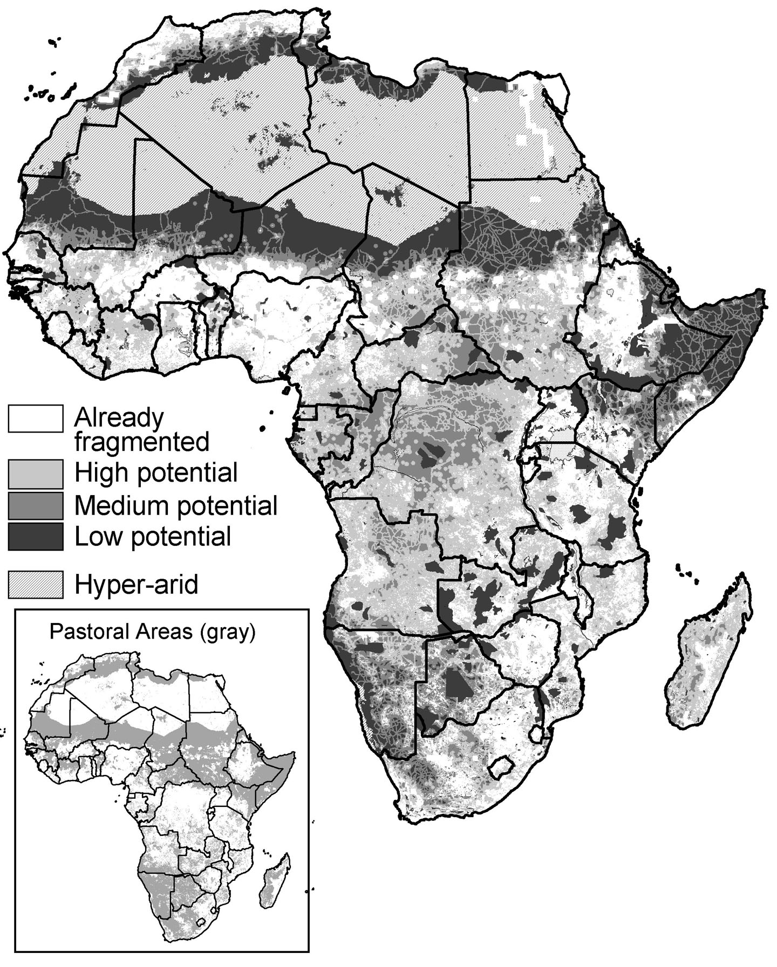

Figure 2. Map of areas where fragmentation is most likely occurring today in African rangelands, from the perspective of a large grazing mammal.

REFERENCES

